NGPF Activity Bank

Investing

FINE PRINT: Renters Insurance Agreement

In this activity, you will explore a Renters Insurance Agreement in more detail to understand its various components. Then, you will answer questions using the sample Renters Insurance Agreement below.

Note: If you find the images below to be too blurry, you can access the original version from Allstate instead, starting on page 5.

Part I: Read The Fine Print:
Directions: Analyze the Renters Insurance Agreement and answer the questions that follow.

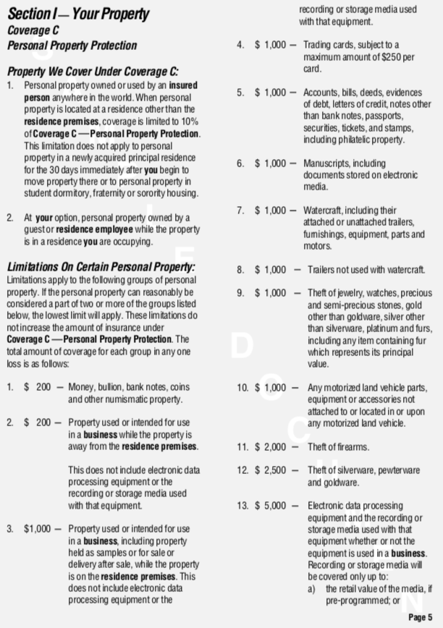

Continues on Next Page

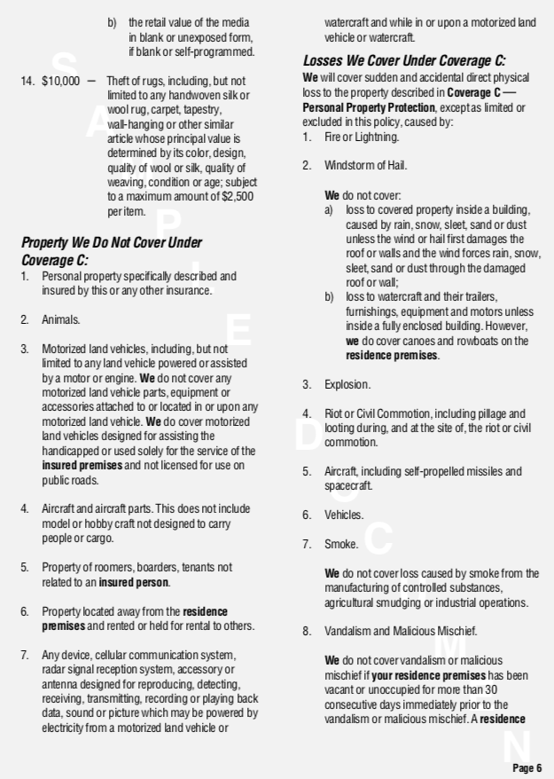

Continues on Next Page

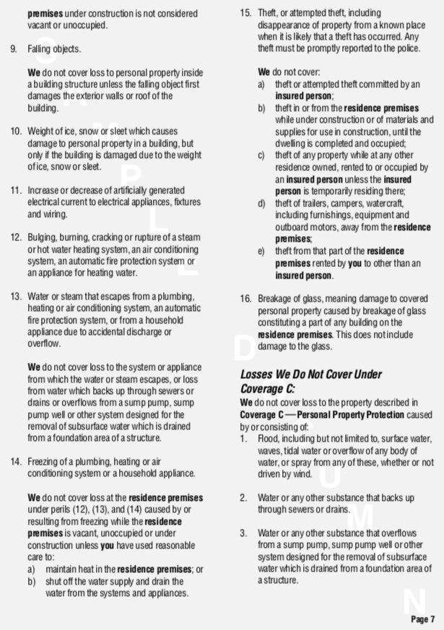

Continues on Next Page

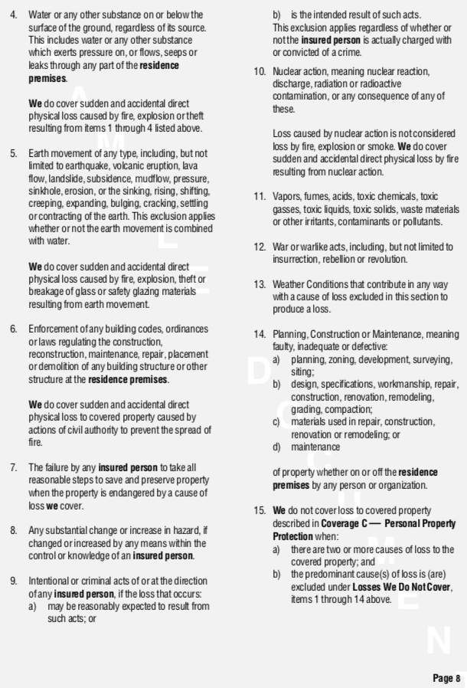

Continues on Next Page

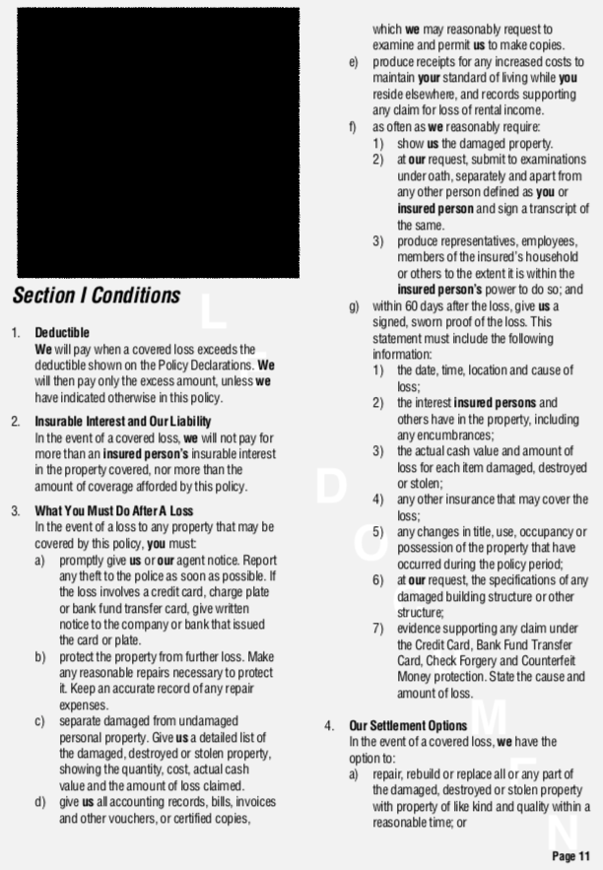

Continues on Next Page

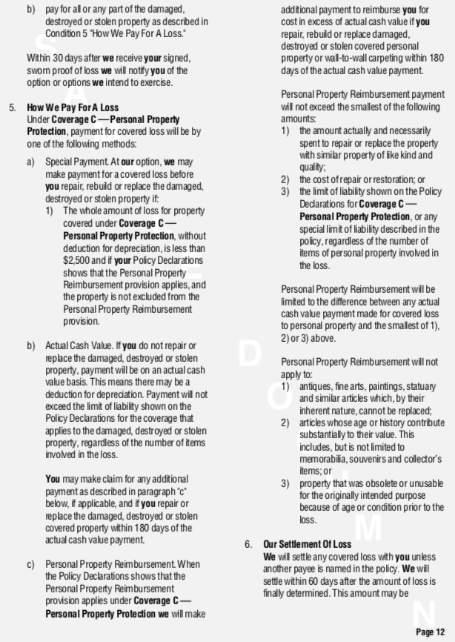

Continues on Next Page
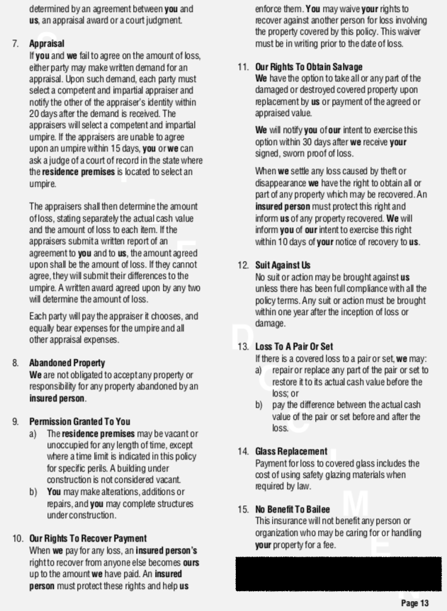

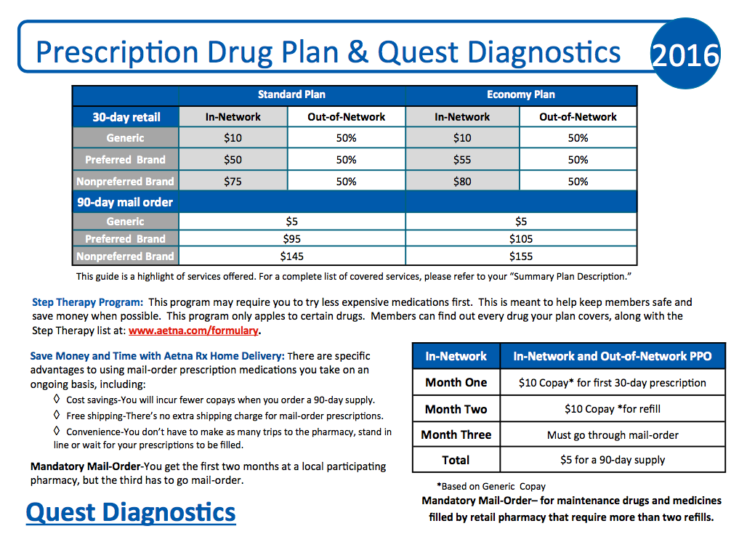

- If you purchase the renters insurance policy described above, you bring a suitcase of clothing and other general items with you on a 3-week stay with your aunt in Panama, and that suitcase is stolen while abroad, how much property coverage will your policy cover?
  - $0, because the items were not AT your apartment during the theft
  - $0, because you were outside the country
  - 10% of your coverage limit, because the items were not AT your apartment during the theft
  - 100% of your coverage limit, because your policy works anywhere in the world

- Which of the following personal property items has the HIGHEST specific limitation on coverage?
  - A prized coin collection
  - Jewelry, watches, and precious stones or metals
  - A canoe you’re storing at the rental property
  - An antique rug

- Megan and her brother Marco have a side business where they shop at flea markets, garage sales, and estate sales to find desirable items, fix them up, and then resell them online for much higher prices. Megan’s apartment is broken into and items valued at $2500 are stolen. How much would her renters insurance cover?
  - $0, because she’d need small business insurance to cover those losses
  - $200
  - $1000
  - $2500

- Keisha is renting a one-bedroom apartment but allows her best friend to move in and pay $200 per month to sleep on the couch for the summer while she is between jobs. The apartment is burglarized one afternoon when they are both out, and the thief steals both of their laptops, Keisha’s TV, and her best friend’s wireless headphones. What will the insurance company cover?
  - None of these items
  - Keisha’s laptop and TV only
  - Keisha’s laptop and TV and 10% of the cost of her friend’s laptop and headphones
  - Keisha’s laptop and TV and her friend’s laptop and headphones

- Which of the following rain-related losses WOULD be covered under this renters insurance policy?
  - Your laptop is ruined because you left your window open during a moderate rain shower
  - Your mattress is ruined because part of the apartment’s roof blew off during a major rainstorm, creating a stream of water landing directly on your bed
  - Your carpet is ruined because your roommate negligently left her wet boots, umbrella, and raincoat sitting in a pile on the rug all afternoon
  - You lose a day’s wages because a horrible rainstorm makes it impossible to get to your job

- Which semi-common emergency event is NOT covered by this insurance policy?
  - Flood
  - Fire
  - Riots and looting
  - Explosions

- Assume this policy has a deductible of $1,000 and a coverage limit of $15,000. If there are personal property losses of $7,000 for a covered event, which best describes how much both parties pay?
  - Insured person pays $0; insurance company pays $7,000
  - Insured person pays $1,000; insurance company pays $6,000
  - Insured person pays $1,000; insurance company pays $7,000
  - Insured person pays $1,000; insurance company pays $15,000

- A tenant with this insurance policy suffers a substantial loss due to lightning strike and an apartment fire that erupts as a result of that storm. The tenant should take each of the following steps as soon as possible EXCEPT…
  - Call the insurance company and report the loss and damages
  - Sign up for additional renters insurance, as this coverage has now been “used up” and will expire
  - Divide property into “damaged” and “undamaged” categories and submit a thorough list of everything “damaged”
  - Provide receipts, when available, for damaged items, costs associated with living elsewhere, and costs of doing any self-repair on the rental property

- The insured person must prepare a report, outlining full details of the loss including all items destroyed, damaged, or stolen and their actual cash value, within...
  - 24 hours
  - 1 week
  - 60 days
  - 180 days

- What happens if the insured tenant and the insurance company fail to agree on the amount of loss?
  - Either the tenant or the company can request an appraisal, so that an impartial third party determines the amount of loss
  - The insurance policy becomes null and void
  - The insurance company is forced to pay the current online market price for the item
  - The landlord or owner of the building must make up the difference in the disputed value

Part II: What Did You Learn?
Directions: Use what you learned from analyzing the Renters Insurance Agreement to answer this question

- In the event that your apartment is damaged or your items are stolen, why would it be important to review a copy of your FULL renters insurance policy documentation?

